Experiment 11
Link Jira tasks with Confluence to streamline task tracking and
progress monitoring for the Library Management System
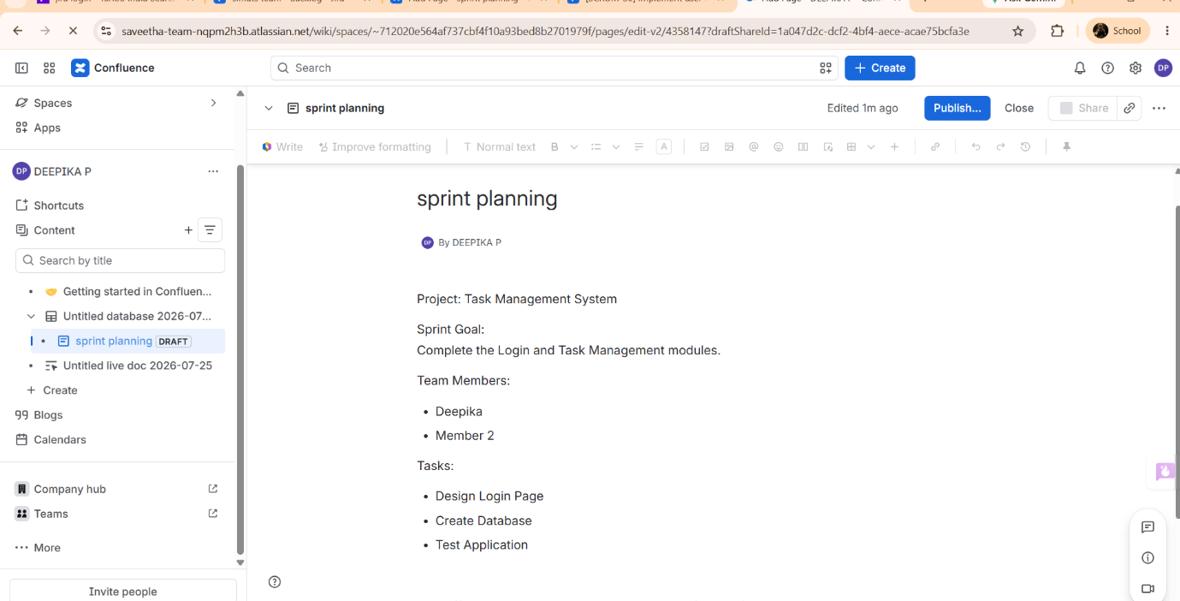
development. Step1:

step2:
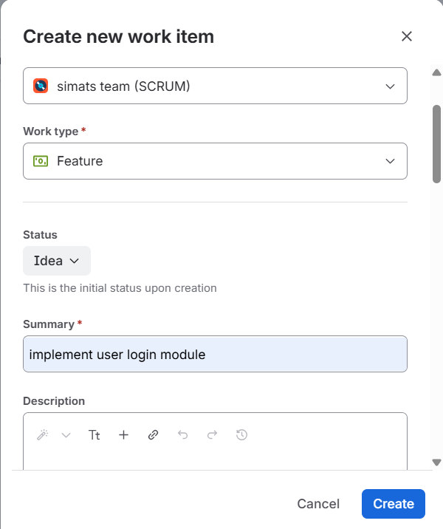

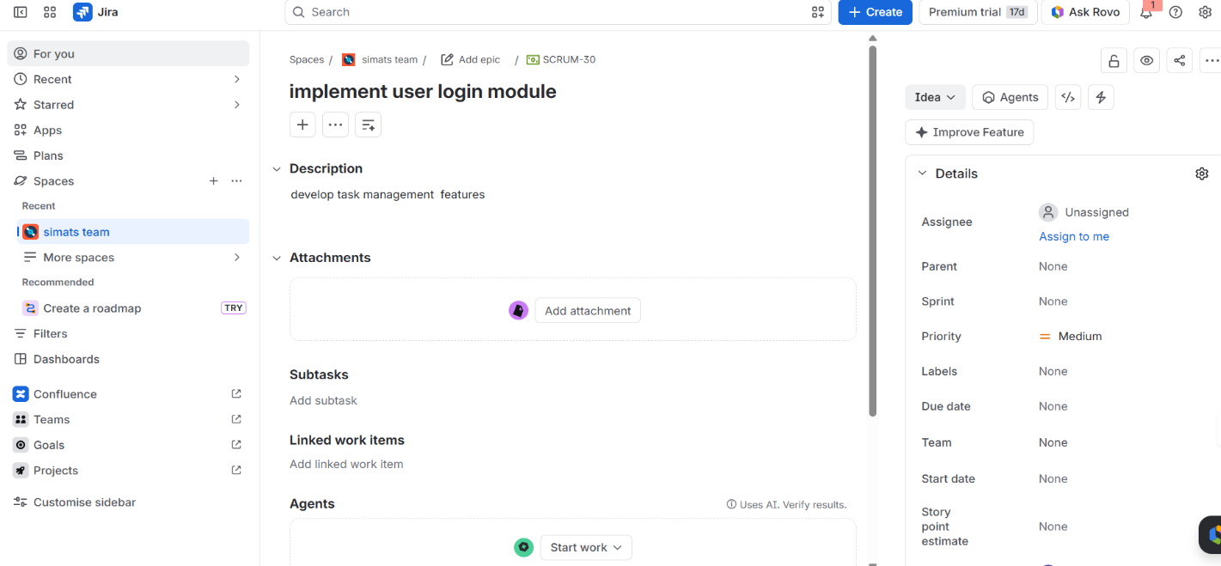
step 3: confluence is linked with jira now
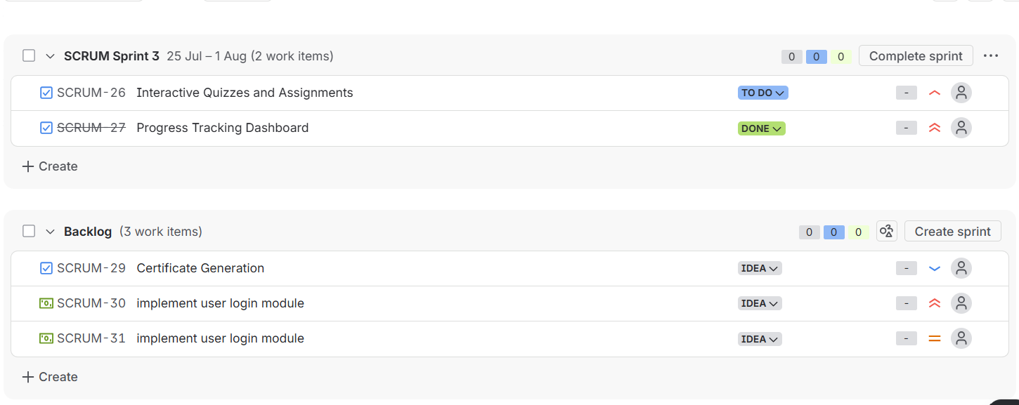
step 5

